**Project Report: Game Lobby system**

## Group 8

**Group members:**

Phạm Minh Hiếu - 23BI14166 - leader

Nguyễn Việt Hưng - 23BI14188

Nguyễn Thành Đạt - 23BI4091

Hoàng Minh Quân - 23BI14371

Vũ Xuân Thái - 23BI14397

Nghiêm Xuân Sơn - 23BI14388

Nguyễn Hữu Phương - 23BI14382

# 1. Problem Description

Build a lobby system that allows multiple players to connect to a central server, create and join game rooms using a room code (6 alphanumeric characters), chat in the room or lobby, and monitor player status.

# 2. Overall Architecture

* Client: User interface (using Terminal), connects to the server, sends and receives commands.
* Server: Manages users, game rooms, and processes communication between clients.

# 3. Features

* User registration and login
* Public chat (lobby) and in-room chat
* Create rooms with random room codes
* Join rooms using a code
* Display current room list
* Player status: online / in game / away
* Notifications when users enter/leave a room
* Handle at least 20 users and 5 rooms simultaneously

# 4. Representative Code

**4.1 Generate random room code – server.py**

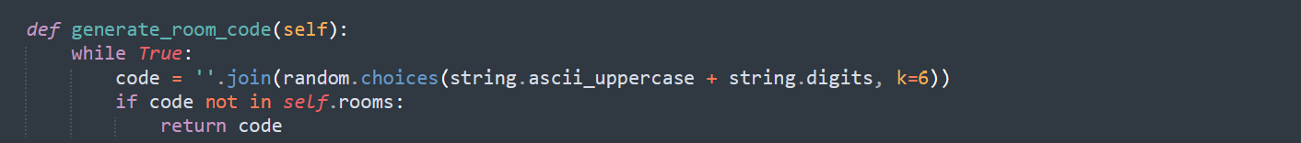

# 4.2 Send messages in room – server.py

# 4.3 Send, receive and display messages – client.py

**5. Execution Results**

**5.1. Registration/Login**

**Interface**

**Response upon successful registration:**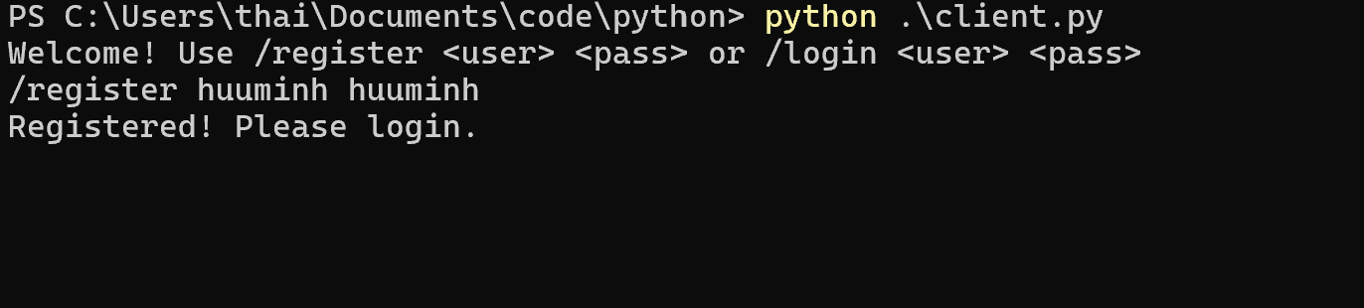

**5.2. Create Room**

**Interface and Result:**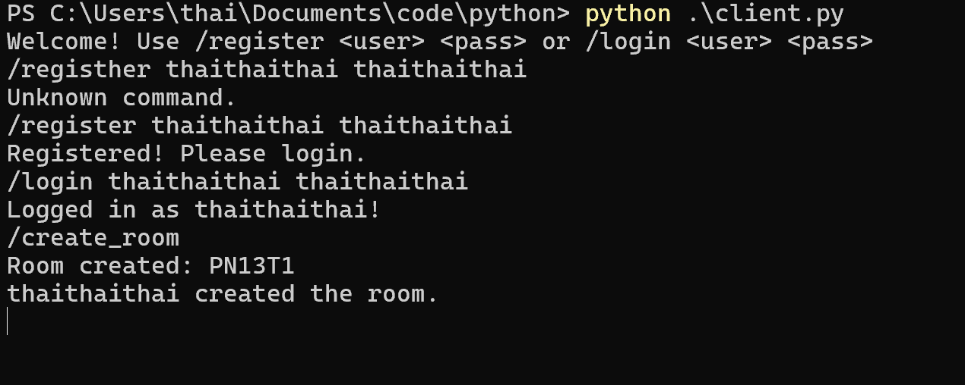

**5.3. Join Room**

**Interface:**

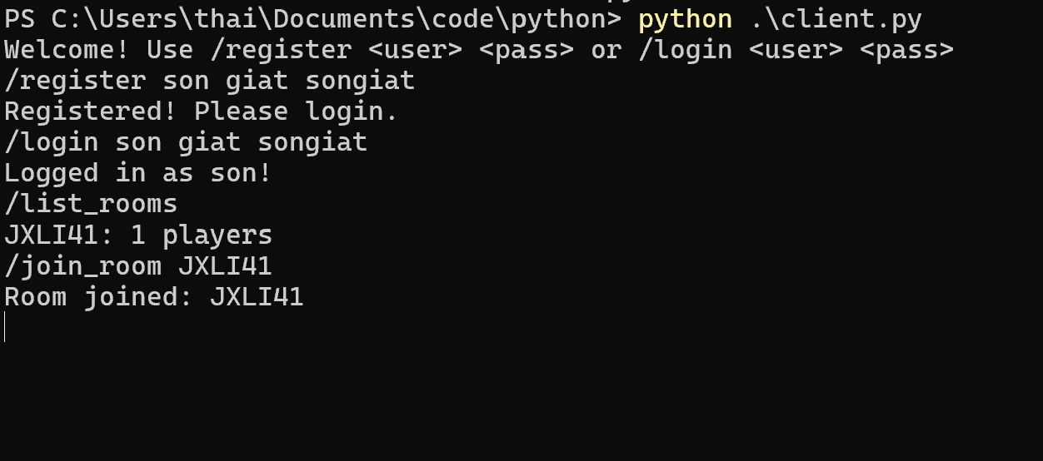

**Result:** 

**5.4. In-room Chat**



# 6. Limitations and Proposed Extensions

## 6.1. Current Limitations

* No password authentication.
* No user data storage.
* Server uses threading, which limits resource handling.
* No data transmission encryption.

### 6.2. Proposed Extensions

* Use a database to store users, rooms, and chat history.
* Secure connections (TLS/SSL).
* Improve performance using asyncio.
* Add features like player invitations, room passwords.
* More enriched UI with avatars, emojis, etc.

# 7. Conclusion

The Game Lobby system meets the basic requirements:

* Supports registration, room creation, room joining
* Communication between players
* Manages status and room data
* Easy to expand and integrate actual games into rooms

**8. Appendix: How to Run the System**

1. **Run server:**



1. **Run multiple clients (each in other devices):**  
   
2. **Interactions:**

- Login, create or join a room

- Chat and manage status